My 2nd great grandfather, John Conway and his wife Sarah Ferrie came to Stirling about 1900. The 1901 census shows them living in Polmont with five children (John, Sarah, James, William and Mary)
The 1911 census shows them living at 38 St Mary's Wynd now with an additional five children (Joseph, Patrick, Rebecca, Michael and Elizabeth). At the outbreak of the First World War John and his son James both volunteered to join the Argyll and Sutherland Highlanders. John lied about his age as he was too old and was eventually sent home due to poor health. The 1915 and 1920 valuation rolls still show John Conway as living at 38 St Mary's Wynd. James ended up in France with the 8th Argylls and was killed in action at Roclincourt on 6th March 1917. Around the same time my great grandfather John was conscripted into the Argylls and also briefly saw action in France. After the war he went back to his job as a miner at Archibald Russell's colliery at Polmaise. Aged 19 he married Helen Kelso at St Mary's Church. They moved to 22 Bow Street and started their own family in 1921 with the arrival of Jane, then John (1922), William (1923), Sarah (1925) James (my grandfather, 1926) Lawrence (1928) and finally, Helen (1931). It is at this generation that my knowledge of the family runs out apart from my own branch of the family tree. I would assume however, that there were children and grandchildren produced by some if not all of the above.
As for my great grandfather John - he joined the TA as part of the 7th Argylls in March 1936. By this time he was living at 14a Weir Street. When war broke out he was sent to France where he fought in the battle of France. He was taken prisoner on 6th June 1940 after a battle near the village of Franleu in France where the 7th Argylls were practically wiped out as a fighting unit. While he was away, the rest of the family moved to 9A Menzies Drive in the Raploch area. He spent the rest of the war in a variety of POW camps until his liberation in 1945. He returned to his job. The last known address I have for him is 26 Robertson place where he lived up until his death in 1978. While he was in captivity, his brother Michael, who had served with the Royal Engineers in North Africa took his own life. Both Michael and John are buried in Ballengeich cemetery near the castle.

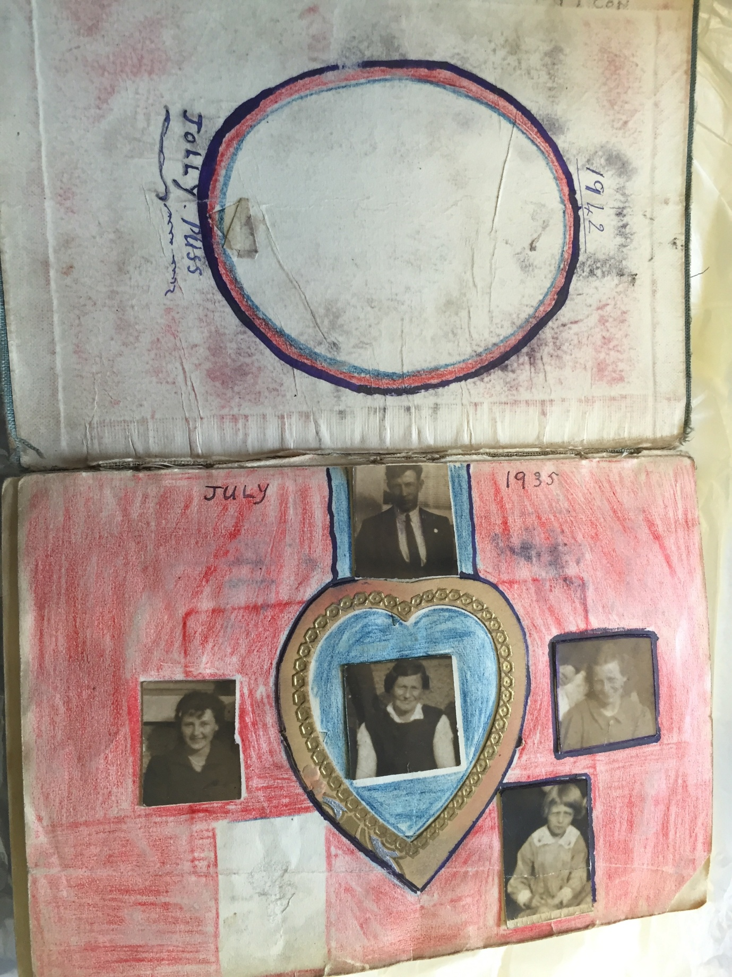
Taken from John's POW logbook - presumably showing his wife and some of his kids.

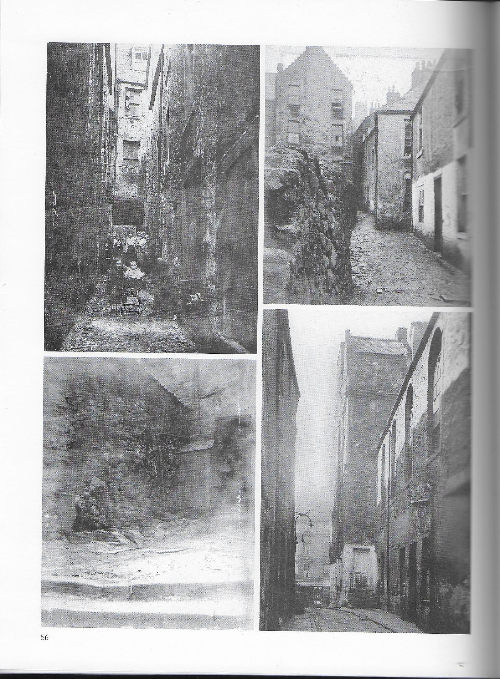

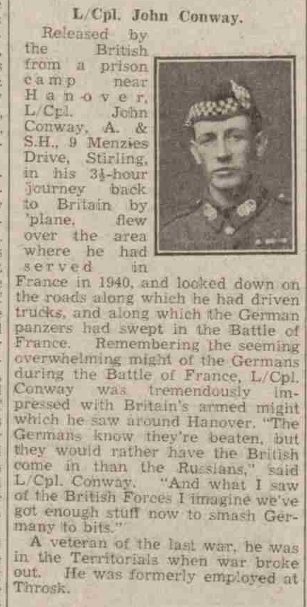

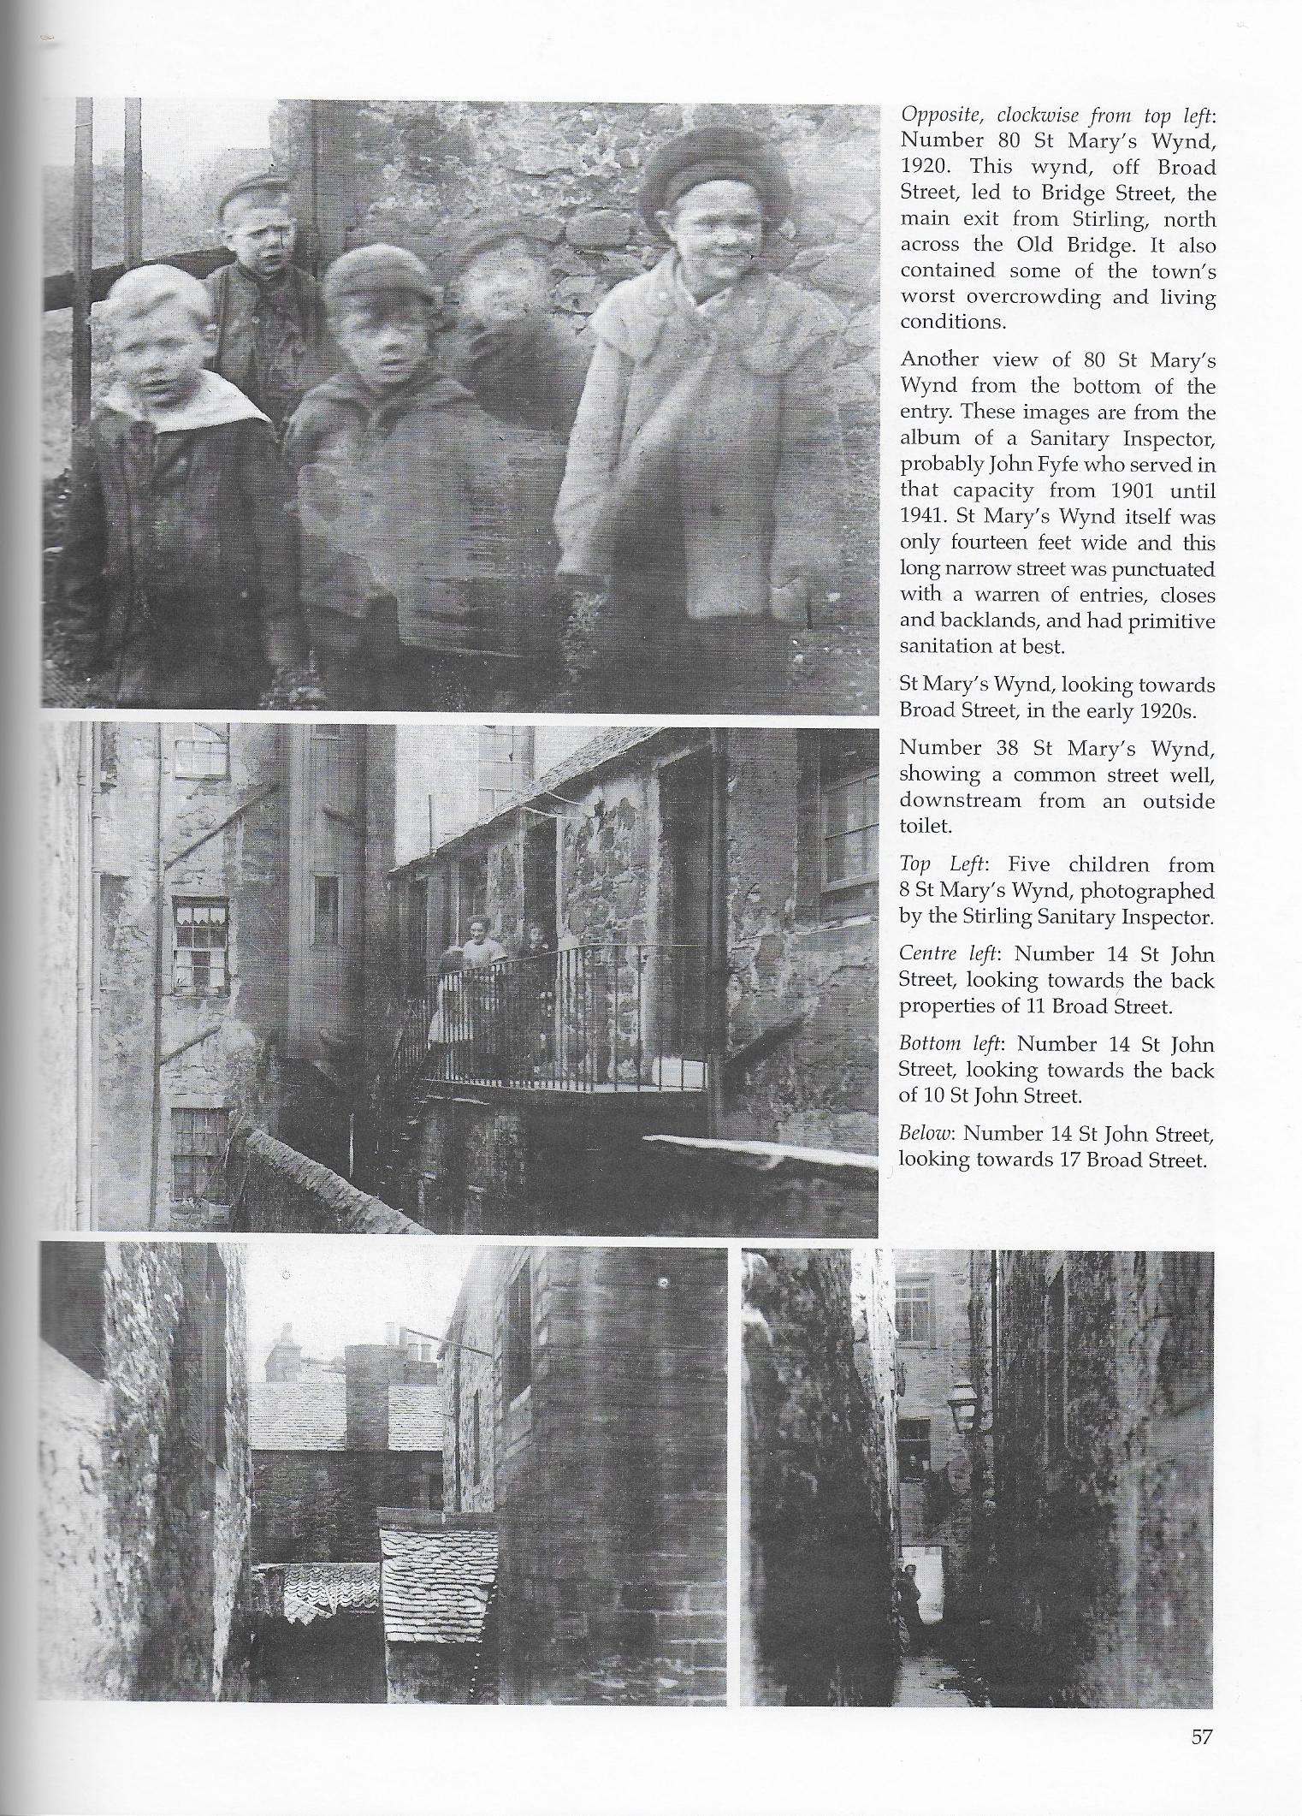

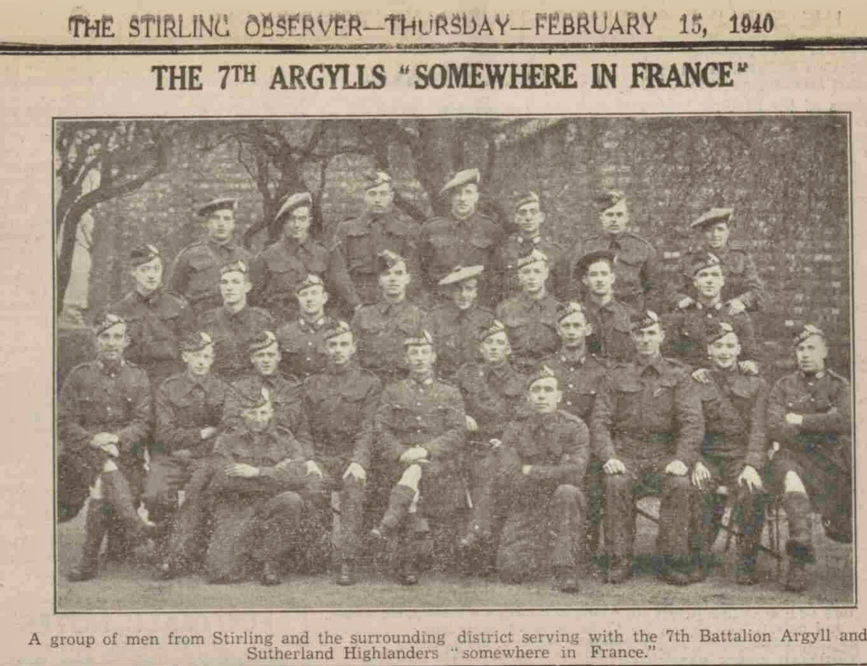
That's great granddad John in the middle of the front row, wearing his kilt and WW1 medal ribbons

