** **

**Plantations Amidst Savagery?**

**The Reformed Monastic Orders in North Europe c.1100 to c.1600**

**Tuesday 9 July to Friday 12 July 2013**

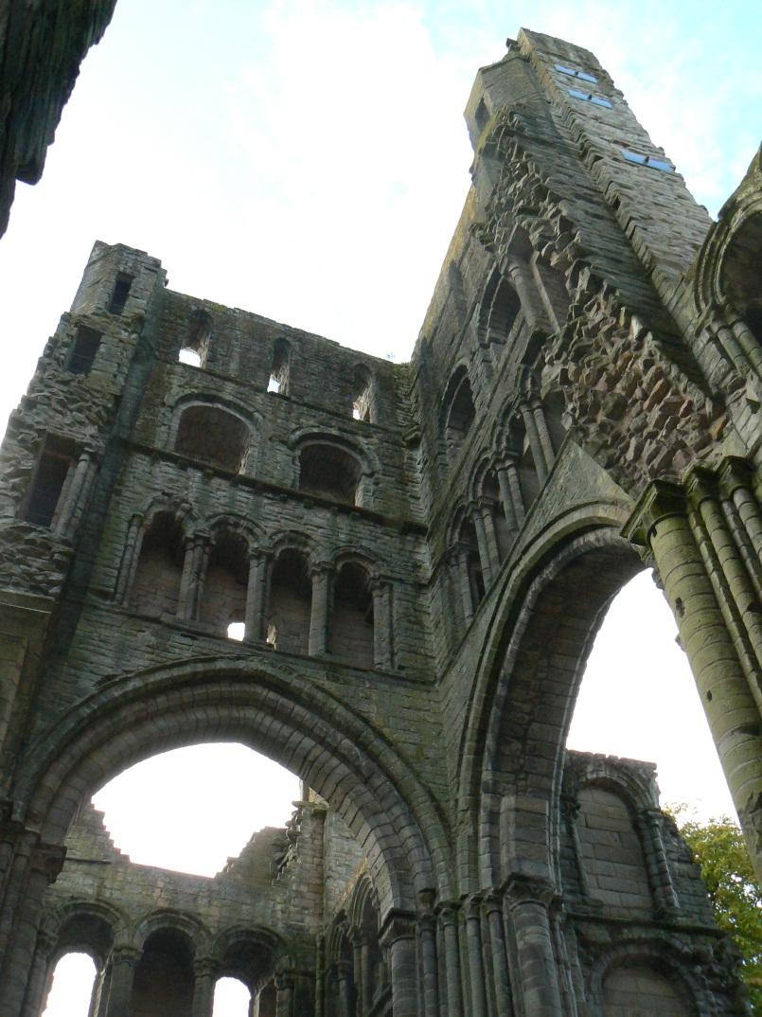

**Programme and Booking Form**

**The conference organisers gratefully acknowledge the support and grant-aid of Historic Scotland towards the costs of this event**

**Programme**

**Tuesday 9 July All main sessions in Pathfoot Lecture Theatre**

14.00-14.15 Welcome

14.15-15.00 *The Start of It All: Selkirk/Kelso and Reformed Monasticism in Scotland*,

Richard Oram

15.00-15.15 Break

15.15-16.45 **Panel 1** – Monks, Nuns and Canons in Northern Europe 1 (Augustinians, Benedictines and Cistercians)

*Chair*: tbc

*Participants*: Oystein Ekroll, *The Augustinian Order in Norway.*

Emilia Jamroziak, *Re-considering the role of Cistercians houses in northern and north-eastern Europe from the twelfth to the fifteenth-century*.

Izzy Hampton, *‘Cherishyng and kepyng in of the love of my lords Westmerland & Nevyll’: Neville Family Patronage at Durham Cathedral*.

16.45-17.30 Break

**Wednesday 10 July**

9.30-11.00 Parallel Sessions

**Panel 2** – New Stories from Old: Reconsidering Monasticism and the Sources in France and Ireland

*Chair*: Erika Lauren Lindgren

*Participants*: Heather Wacha, *Women and the Abbey of Premontre: The Sources Revisited*.

Yvonne Seale, *Loughsewdy alias Plary: a Cistercian Nunnery Reconsidered.*

Chris McFadin, *Women and the Militarization of the Knights of St. John.*

**Panel 3** – Monastic Art, Architecture and Material Culture – from spires to sewers

*Chair*: tbc

*Participants*: Richard Fawcett, *The Architecture of the Valliscaulian Order in Scotland*.

Derek Hall and George Haggarty, *Monks, nuns, pots and tiles - ceramic material culture and Scottish monastic houses.*

John Malden, *Paisley Abbey Drain and Its Contents*.

**Panel 4** - A Clash of Cultures? Monasteries and Noble Patrons [Sponsored by History Lab Plus, IHR (London)].

*Chair*: Emilia Jamroziak

*Participants*: Jonathan Gledhill, *Natives, Normans and Monastic Patronage in 12th Century Scotland.*

Adam Chapman, *Neighbours from Hell: The Parrys and the Cistercians of Dore, 1397-1510*.

11.00-11.30 Coffee

11.30-13.00 **Plenary 1** Constance Berman, *Amelioration and Investment by Cistercian Monks and*

*Nuns*

14.30-16.00 Parallel Sessions

**Panel 5** – Benedictine Networks and Networking in the Long 12th Century: New Approaches [Session sponsored by Conventus ([http://www.conventus.ugent.be](http://www.conventus.ugent.be/)) and the Research Foundation-Flanders ([http://www.fwo.be](http://www.fwo.be/))].

*Chair*: tbc

*Participants*: Koen Vanheule, *A dynamic approach to abbatial networking: the pros and cons of working with databases*.

Tjamke Snijders, *“Litterae unius coloris fiant”: Between ideological networks and initials in the 12th century Low Countries*.

**Panel 6** – Monastic Life: the Cloister and the World Beyond

*Chair*: tbc

*Participants*: Mark Hall, *“plus ça change …” playtime reformed for the brothers and sisters?*

Lene Myrdal, *Monasteries and Monks Serving Secular Purposes.*

Julie Kerr, *Monastic Hospitality and the New Religious Orders.*

**Panel 7** - Female Religious Houses in Britain and Ireland [Sponsor: History of Women Religious of Britain and Ireland (H-WRBI)].

*Chair*: Judith Frost

*Participants*: Kimm Curran, *Towards a typology of sites? Female religious houses in Scotland.*

Tracy Collins, *Female Monastic Orders in Later Medieval Ireland: an archaeological approach.*

Linsey Hunter, *Cistercian Sophistication?: Legal Aspects of the acta of Female Cistercian Houses in Scotland and Wales.*

16.00-16.15 Break

**Thursday 11 July**

9.30-11.00 Parallel Sessions

**Panel 8** – Tradition and Reform in the Anglo-Scottish Borderlands

*Chair*: tbc

*Participants*: Neil McGuigan, *The Church of Lothian Before the Scoto-Norman Era*

Richard Oram, *The Premonstratensians in Scotland*

Judith Frost, *When I find myself in times of trouble’: spiritual networks on the Borders*.

**Panel 9** - Monks, Nuns and Mendicants in Northern Europe (Cistercians, Cluniacs and Franciscans)

*Chair*: tbc

*Participants*: Colman O’Clabaigh, *Cistercians in Ireland: Frontiers and Ethnicity*.

Yvonne McDermott, *Ross Errilly Franciscan friary: A rural house of the Observant reform in late medieval Ireland.*.

Hannelore Pepke-Dirix, M*onastic Burgundy and the North: spiritual radiance and economic exchange*

11.00-11.30 Coffee

11.30-13.00 **Plenary 2** Janet Burton, The Regular Canons: an overview of recent historiography in

a British context.

14.30-16.00 Parallel Sessions

**Panel 10** – Geophysical Survey and 3D Visualisation – interpretative tools

*Chair*: tbc

*Participants*: Audio-visual presentations on

1. The Abbey of Cluny
2. St Andrews Cathedral-Priory

Oliver O’Grady, *Geophysical Surveys at Scottish Monastic Centres: Scone, Loch Leven, Inchmahome and Dunkeld.*

**Panel 11** – Sources and Histories: Property and Identity

*Chair*: tbc

*Participants*: Richard Millar, ***The Monastic Cartularies of Scone Abbey and the Wider Documentary Framework.***

Brian Golding, *Creative histories : fact and fiction in the foundation accounts of Stone priory and Dale abbey***.**

Anna Campbell, *St Colette of Corbie (1381-1447): Absolute Poverty and Property Disputes*

**Booking Form**

Name:………………………………………………………………………………………………………………………………………………….

Address:………………………………………………………………………………………………………………………………………………………………………………………………………………………………………………………………………………………………………………………………………………………………………………………………………………………………………………………………………………………………………………………………………………………………………………………………………………………………………

Telephone contact no (including area dialling code):………………………………………………………………………….

Email address:……………………………………………………………………………………………………………………………………..

Vegetarian [ ]

Special dietary needs [ ] (Please specify, e.g. gluten-free)…………………………………………………………………

…………………………………………………………………………………………………………………………………………………………

**Conference Registration** [tick as appropriate]

Per Day Full Concessions (unwaged and PG)

Registration + Teas/Coffees Day 1 £15.00 [ ] £10.00 [ ]

Registration + Teas/Coffees/Lunches Day 2 £45.00 [ ] £30.00 [ ]

Registration + Teas/Coffees/Lunches Day 3 £45.00 [ ] £30.00 [ ]

Days 1-3 inc Teas/Coffees/Lunches £105.00 [ ] £70.00 [ ]

Please make cheques payable to: **University of Stirling**

Postal Address: Please mark all correspondence –

**FAO Mrs S Armstrong-Payne,**

**Plantations Amidst Savagery,**

**History and Politics,**

**School of Arts and Humanities,**

**University of Stirling**

**Stirling FK9 4LA**