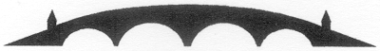

Charity NO SCO 38247
Stirling Local History Society
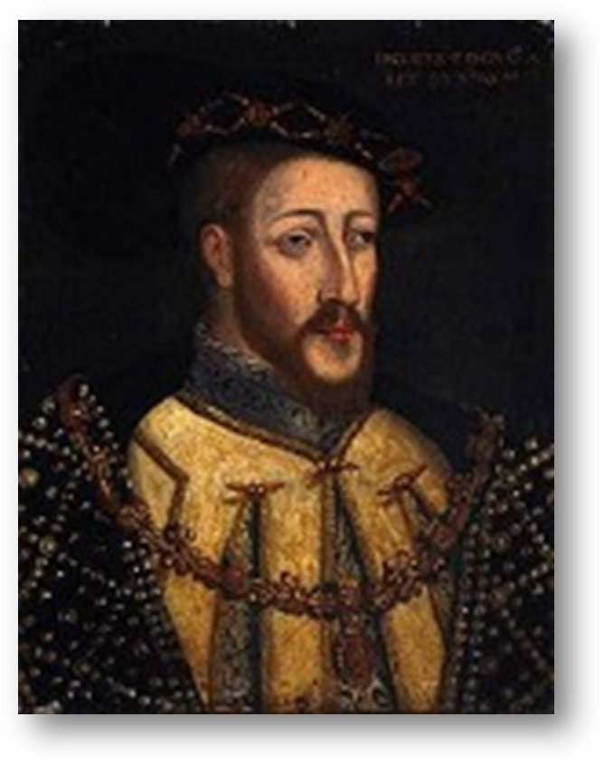
Guest Speaker : Dr Lucy Dean, Stirling University
Projecting ‘Princelie Majestie’ in the Reign of James V: Ceremony, Ritual and the Visible Monarch
In the Stirling Smith Art Gallery and Museum
Dumbarton Road, Stirling, FK8 2RQ
On Thursday 25th February 2016 at 7.30pm

All Welcome Members free - Visitors: £2.50
For further details please contact - The Secretary at 01786 471809

