

**Charity NO SCO 38247**

**Stirling Local History Society**

Meeting: Thursday 29th September 2022 at 7.30pm

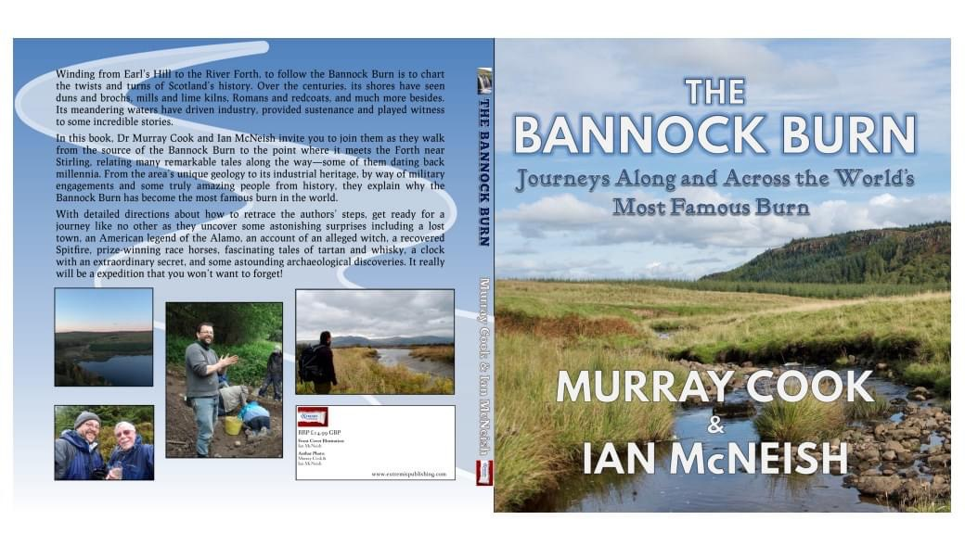

Guest Speakers : Murray Cook & Ian McNeish

“The Bannock Burn :

***Journeys Along and Across the World’s Most Famous Burn*”**

in the Stirling Smith Art Gallery and Museum

Dumbarton Road, Stirling, FK8 2RQ

All Welcome Members and Visitors **For further details -** [enquire@stirling-lhs.org](mailto:enquire@stirling-lhs.org)