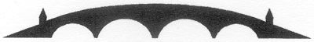

Charity NO SCO 38247
Stirling Local History Society
Meeting : 27th September 2018
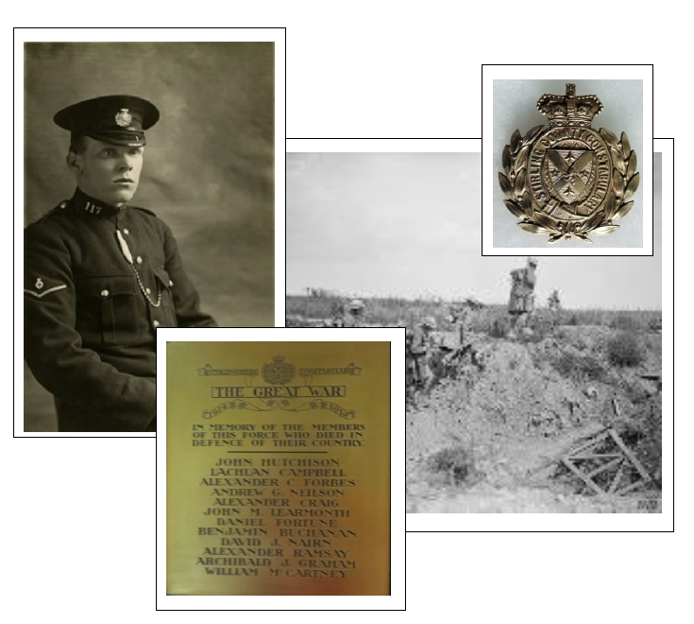
Guest Speaker : Gary Lawrie, PG Dip, QG. Professional Genealogist, Heart of Scotland Ancestry
“A Call of Two Duties - Stirlingshire Constabulary in WW1”
In the Stirling Smith Art Gallery and Museum
Dumbarton Road, Stirling, FK8 2RQ
All Welcome Members free Visitors: £2.50
For further details please - enquire@stirling-lhs.org

