Landscape Legacies of Coal

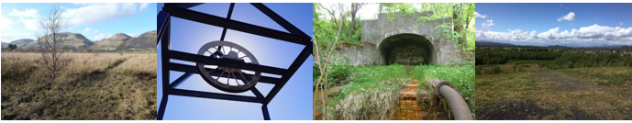

Do you remember the coal industry in central Scotland when the bing, the headstock, colliery buildings, the railway sidings and the associated housing, clubs and bowling greens dominated the landscape.
We are trying to capture the history of colliery sites from closure to present day:
- Did you watch the demolition and/or the landscaping of the bing?
- Did you play on the sites as a youngster?
- Do you still visit the site?
- Do you miss the headstock in the landscape?
- Does the site hold special memories or evoke feelings for you?
If you have stories and memories that you are willing to share and you would like participate in an oral history interview please contact either Ian ian.mcIntosh@stir.ac.uk or Catherine c.j.mills@stir.ac.uk
Alternatively, if you have 10 minutes to spare please complete our on-line questionnaire at https://stirling.onlinesurveys.ac.uk/landscape-legacies-of-coal

Find us on Facebook page and have a look at our website
https://www.facebook.com/landscapelegaciesofcoal/
www.landscapelegaciesofcoal.com

