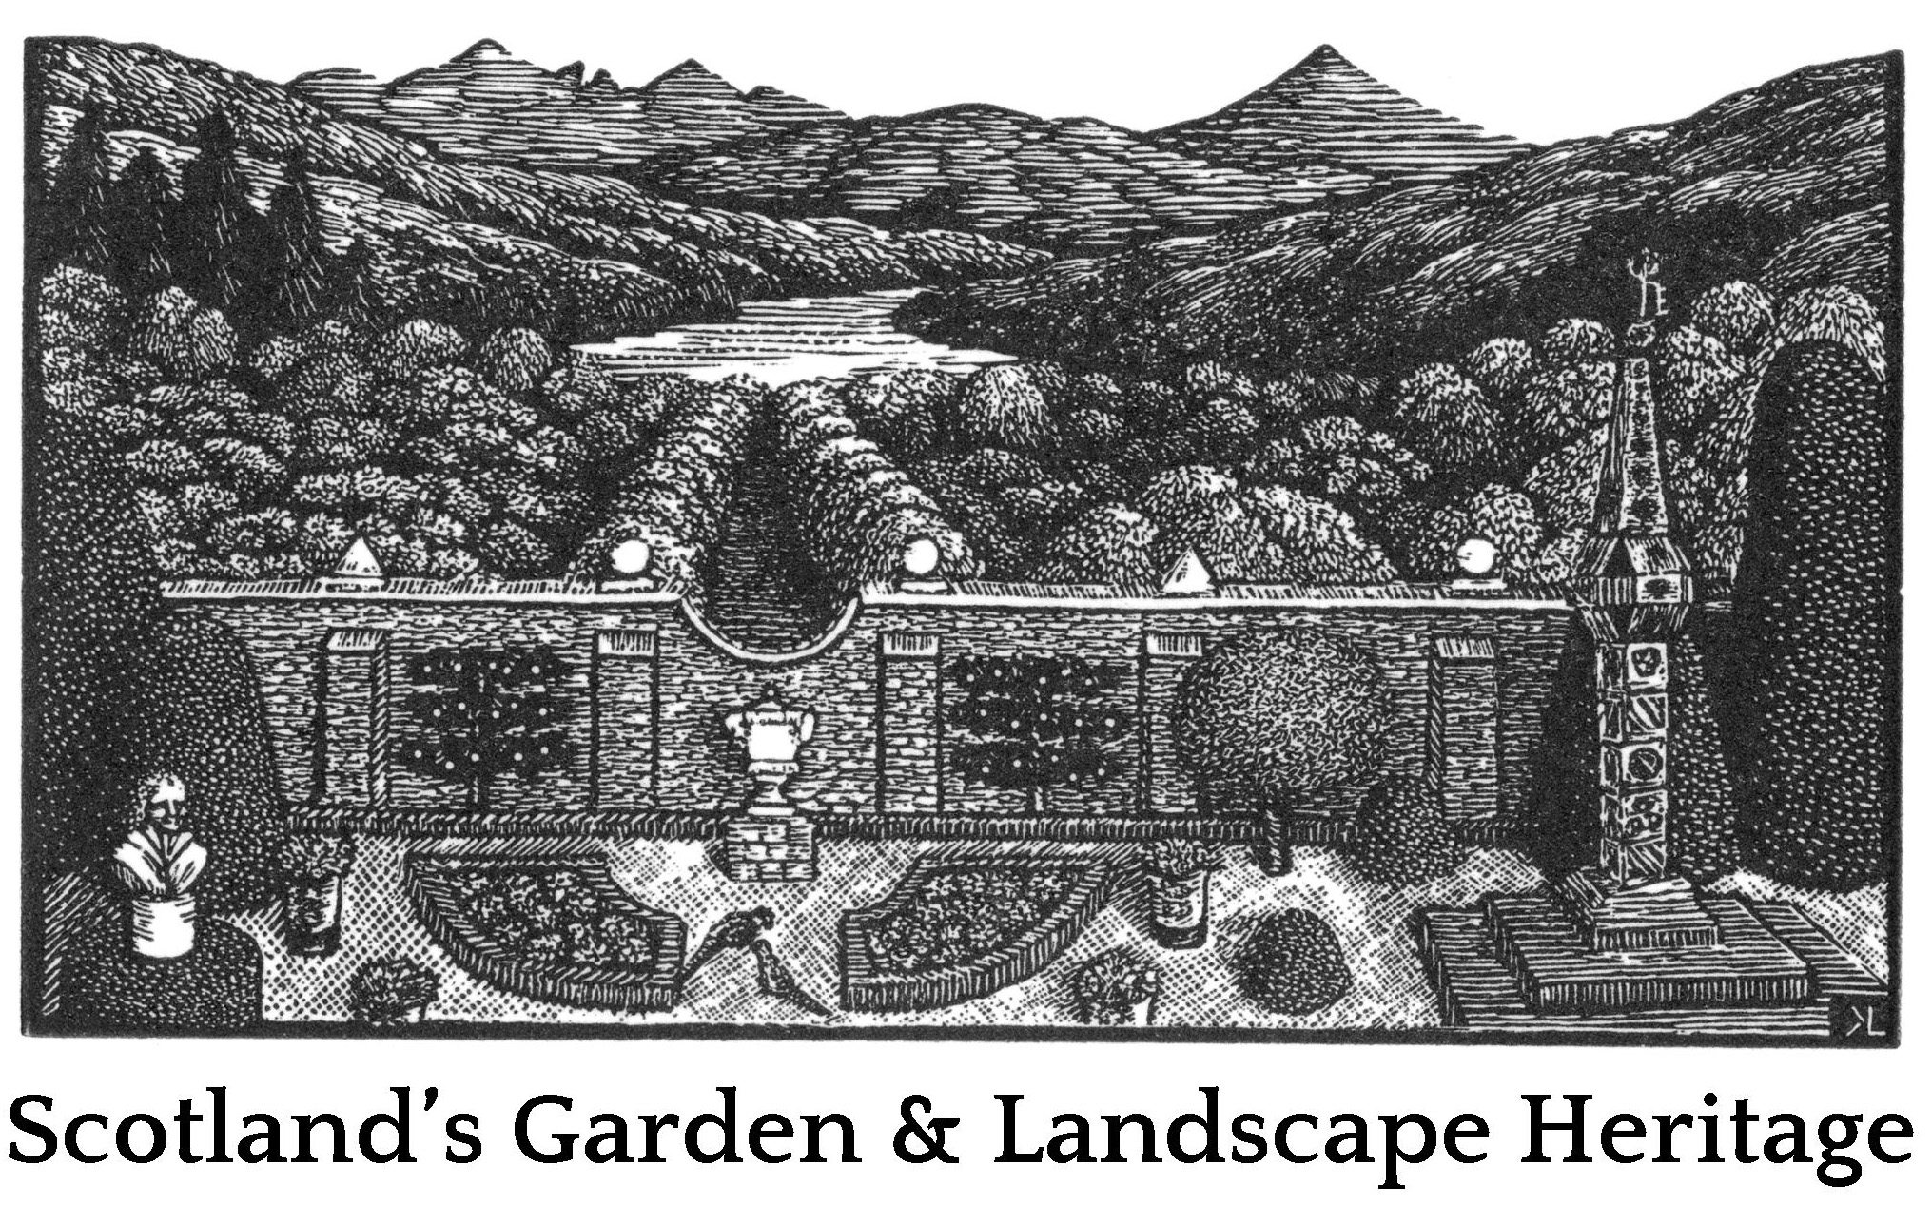

Research Seminar
Wednesday 27th September 2017
Sandeman Room, AK Bell Library, Perth
10.00 to 15.30

Name:

Institution or affiliation ( ie university or organisation if applicable):

Email address:

Mobile number:

Research interest(s):

Dietary requirements:

Please retain the invitation as it contains information that you will need for the seminar.

Please return the form by email to info@sglh.org.
There are only 20 places to be allocated on a 'first come' basis.

