Stirling’s Lost Broch

Christian Maclagan (1811–1901), arguably Scotland’s first female archaeologist, lived in Stirling and was buried in the Old Town Cemetery. She is often credited with being one of the first people to undertake modern stratigraphic recording and in 1870 she identified a possible broch structure at Livilands. Unfortunately, she suffered from contemporary sexism and her work was overlooked and the broch ‘lost’. Indeed her first paper to the Society of Antiquaries of Scotland had to be transcribed by a man.

Dr Murray Cook is launching a Crowdfunding campaign to help rediscover Stirling’s lost broch……can you help?

Crowdfunding campaign http://digventures.com/projects/lost-broch-2016/

Project website https://christianmaclagan.wordpress.com

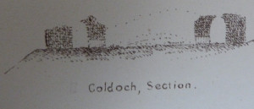
Maclagan’s 1875 section of Coldoch broch: the world’s first section?

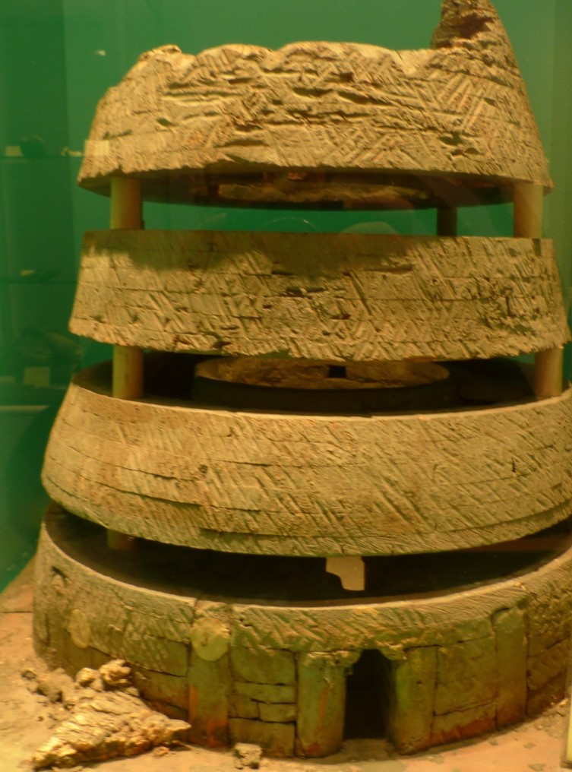

Maclagan’s reconstruction of a broch in the Smith Museum

