

**Charity NO SCO 38247**

**Stirling Local History Society**

Meeting: Thursday 28th March 2024 at 7.30pm

**Guest Speaker** : Dr Valentina Bold

***Stirling Street Poetry***

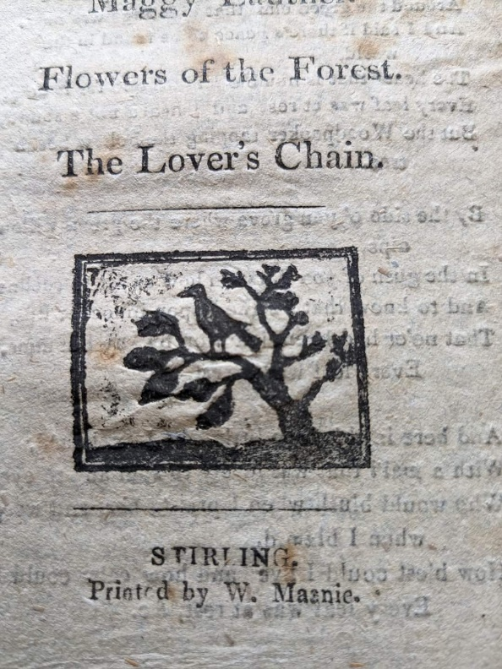

in the Stirling Smith Art Gallery and Museum

Dumbarton Road, Stirling, FK8 2RQ

All Welcome : Members free, visitors £3.00

**For further details -** [enquire@stirling-lhs.org](mailto:enquire@stirling-lhs.org)