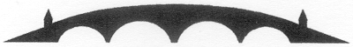

Charity NO SCO 38247
Stirling Local History Society

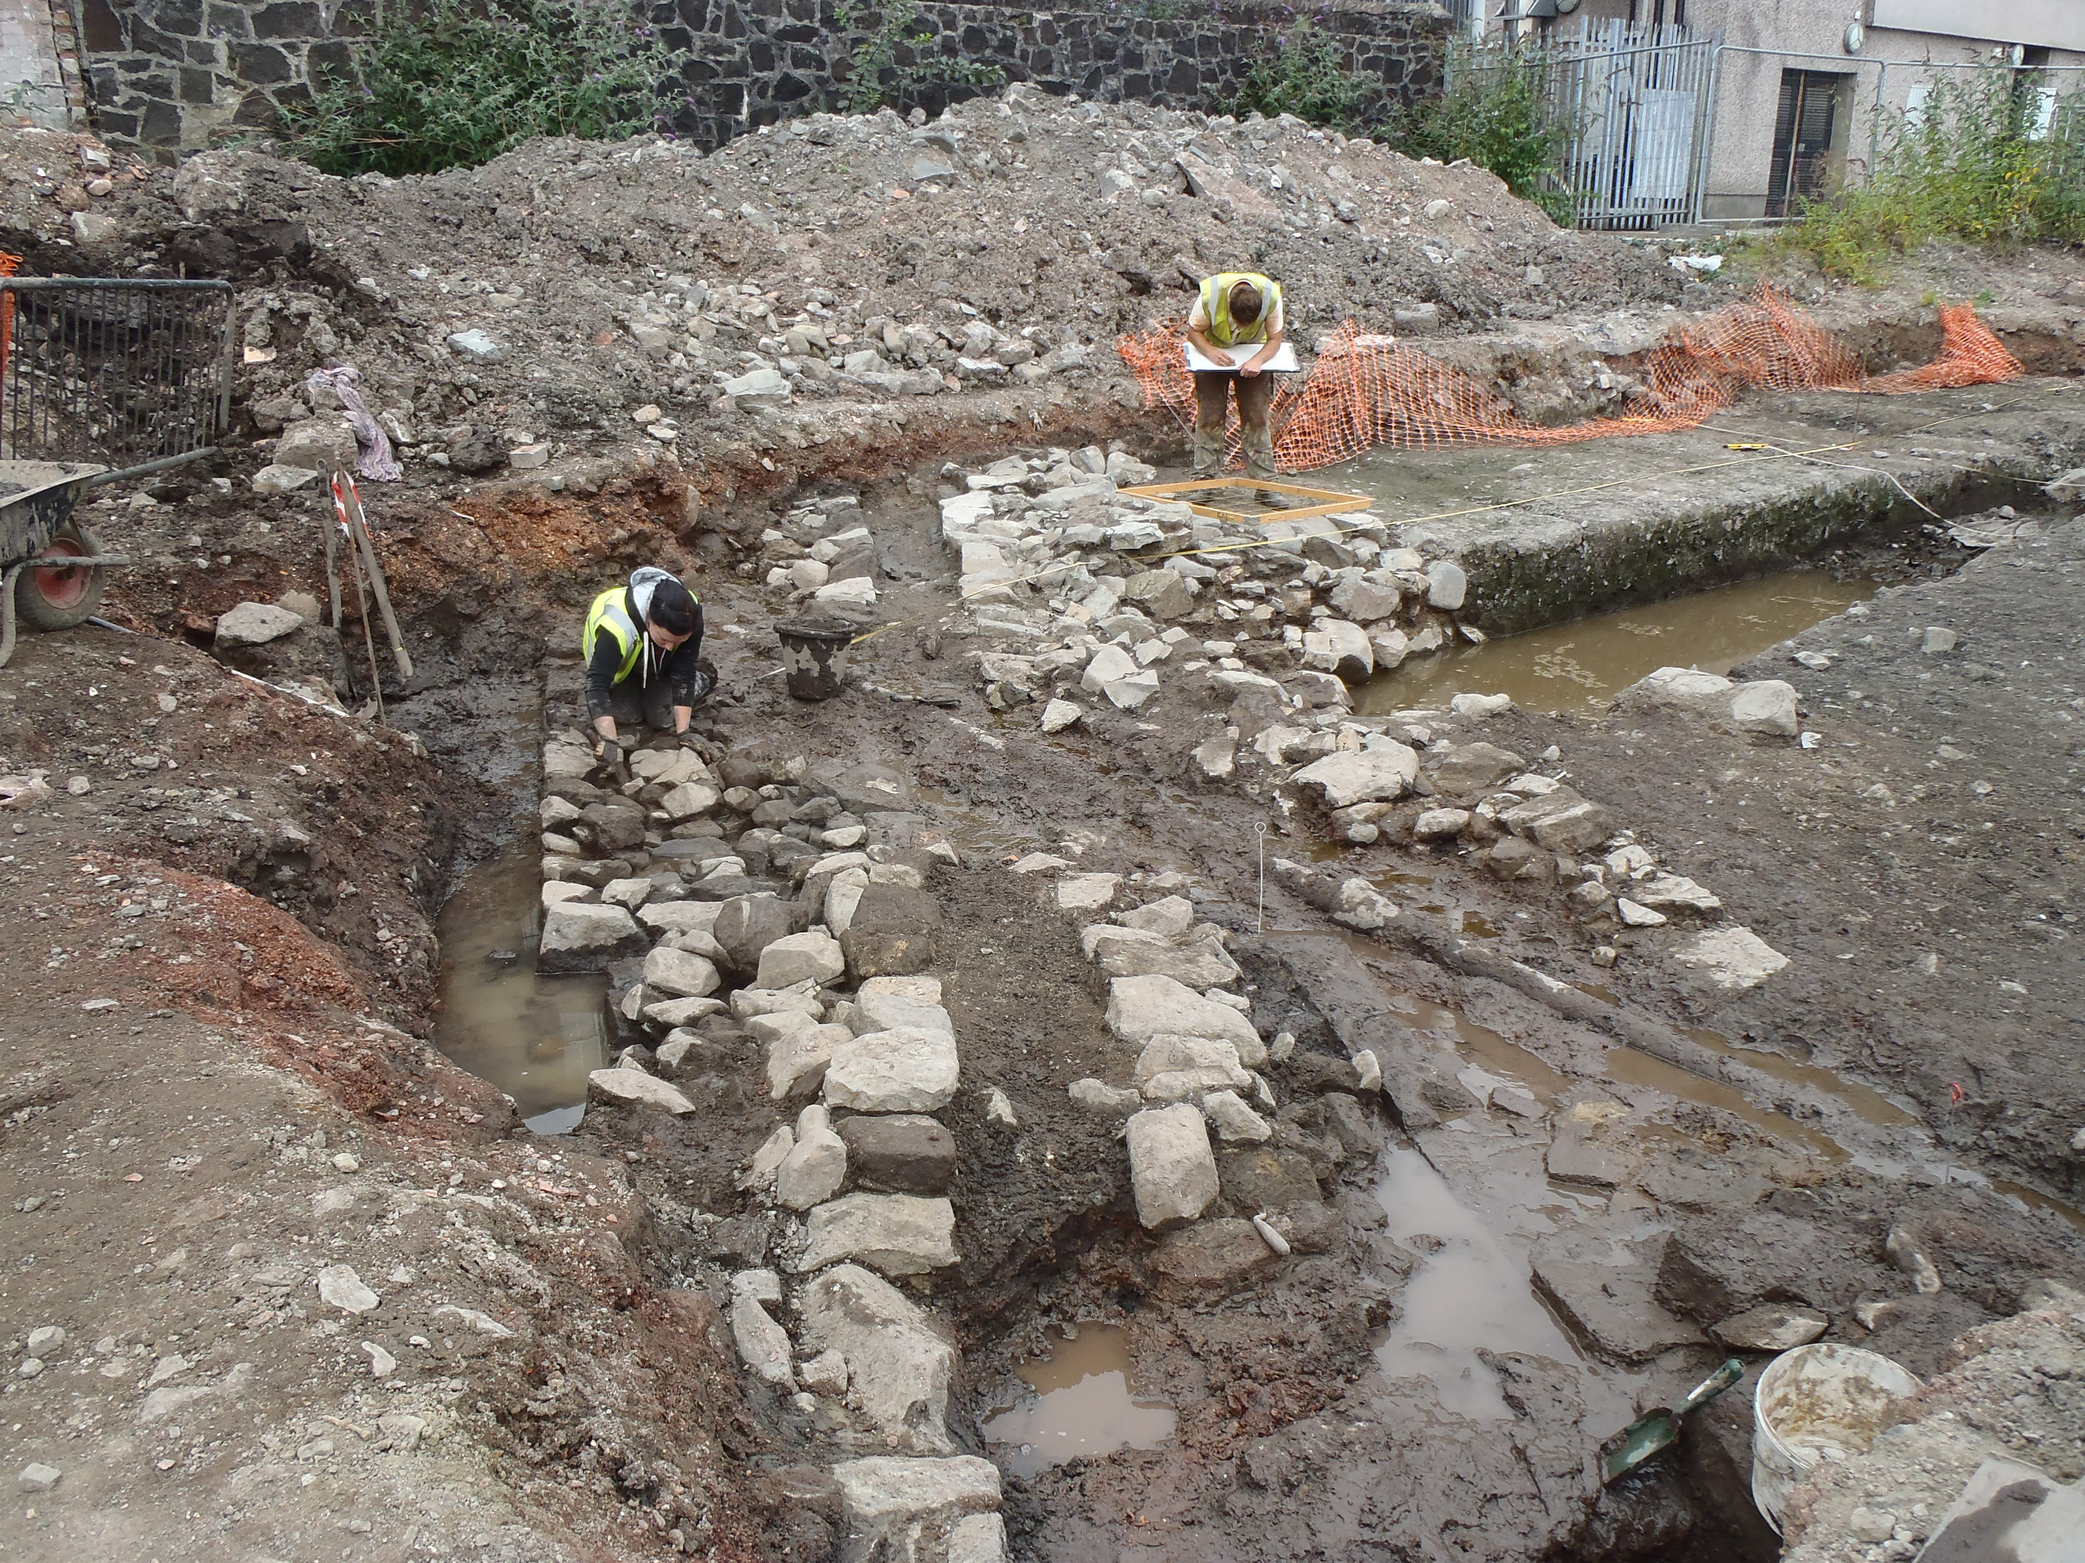

Guest Speaker : Bob Will, Guard Archaeology
“ Blackfriars Monastery Dig”
In the Stirling Smith Art Gallery and Museum
Dumbarton Road, Stirling, FK8 2RQ
On Thursday 31st March 2016 at 7.30pm

All Welcome Members free - Visitors: £2.50
For further details please contact - The Secretary at 01786 471809

