

**Charity NO SCO 38247**

**Stirling Local History Society**

Meeting: Thursday 30th March 2023 at 7.30pm

**Guest Speaker** : **Tara Leishman**

© Tara Leishman ***Legacies of Slavery in Stirlingshire and Perthshire***

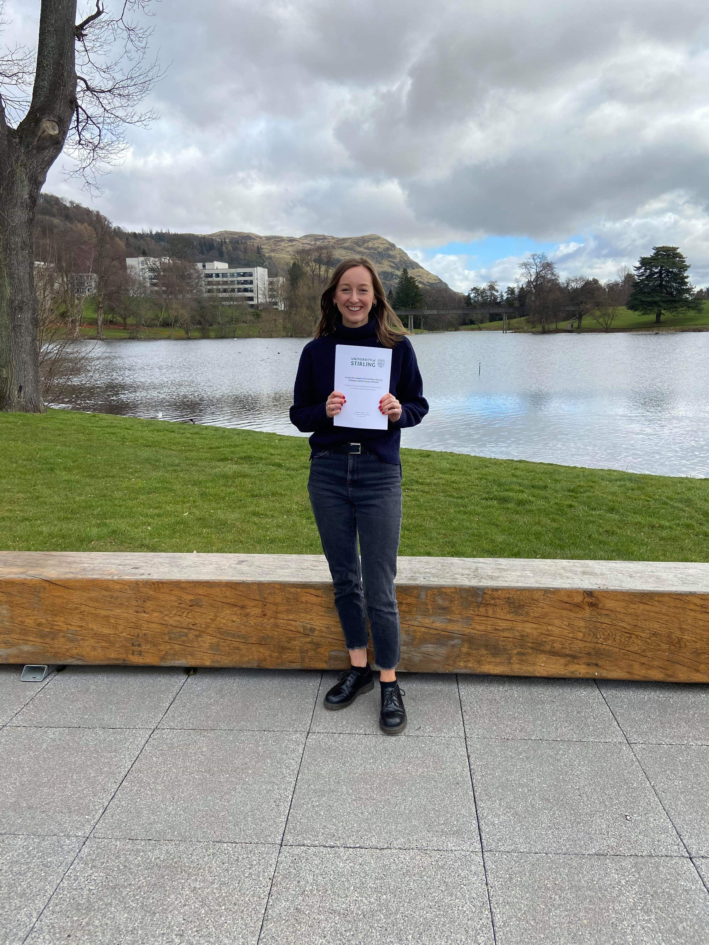

in the Stirling Smith Art Gallery and Museum

Dumbarton Road, Stirling, FK8 2RQ

All Welcome Members and Visitors Free

**For further details** [**Stirling-lhs@outlook.com**](mailto:Stirling-lhs@outlook.com)